- Install TortoiseSVN
  - Go to http://downloads.sourceforge.net/tortoisesvn/TortoiseSVN-1.5.0.13316-win32-svn-1.5.0.msi?download
  - Run the installer.
  - Restart computer.

- Create a new folder to hold SWAT files
  - Example folder: C:\OpenSource\SWAT

- Check out SWAT from SVN
  - Right click on the new folder you created and select “SVN Checkout”
    - 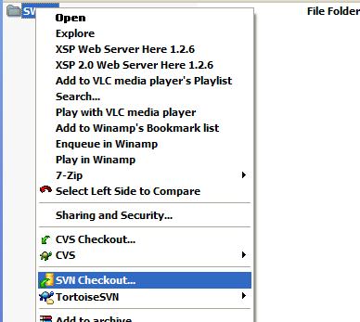

  - Fill out the Checkout parameters. Your fields should look like mine below
    - 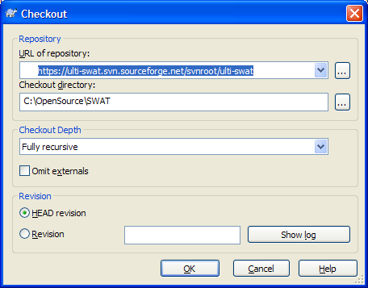

  - Save Authentication
    - The first time you perform a commit you will be prompted for your sourceforge credentials. Enter your credentials and make sure you check “Save Authentication” that way it won’t keep asking you for your username and password on every commit.
